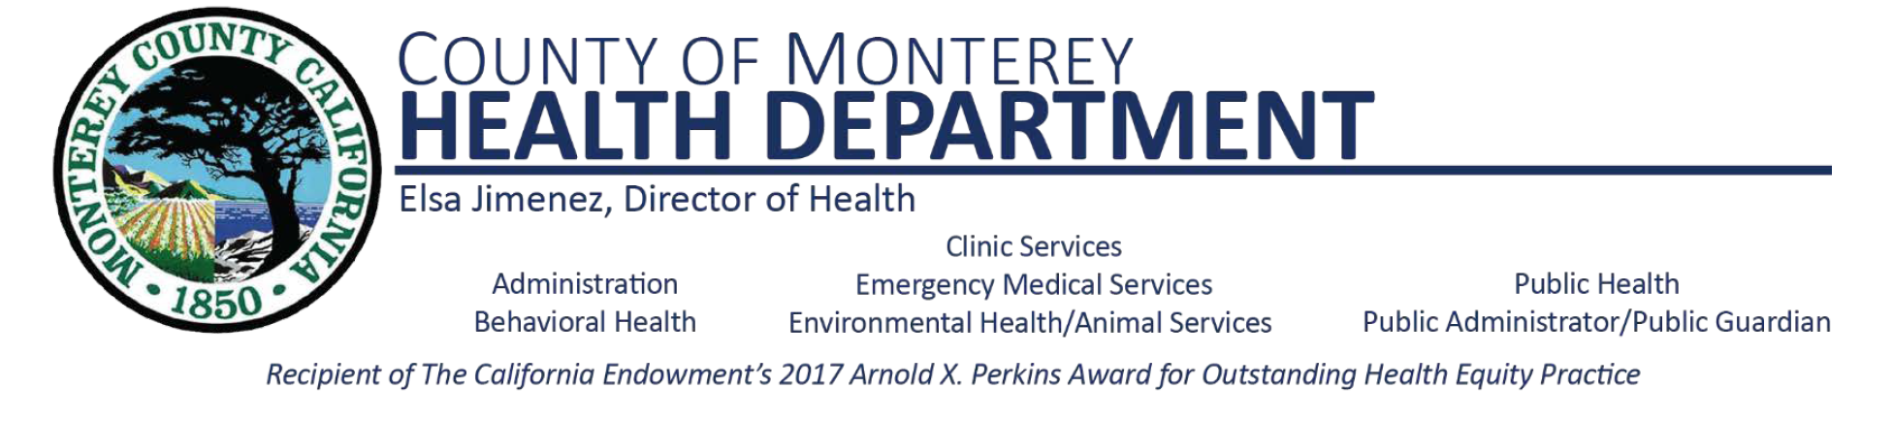

**Oral Health Advisory Committee Meeting**

**Agenda**

Wednesday, March 9th, 2022

2:00 pm –3:00pm

1. Welcome & Introductions
2. Partners & Agency Announcements
3. Children’s Oral Health Month
   1. Media & Outreach – Maria Lopez
   2. Kinder Round Ups & Kinder Oral Health Assessment
4. CHDP Provider Lists – Alejandra Garcia
5. Online Parent Workshops
   1. School sites
   2. Preschool – Early Learning Program
6. Student in-person presentations
7. Oral Health Program Updates
8. Meeting Adjourn