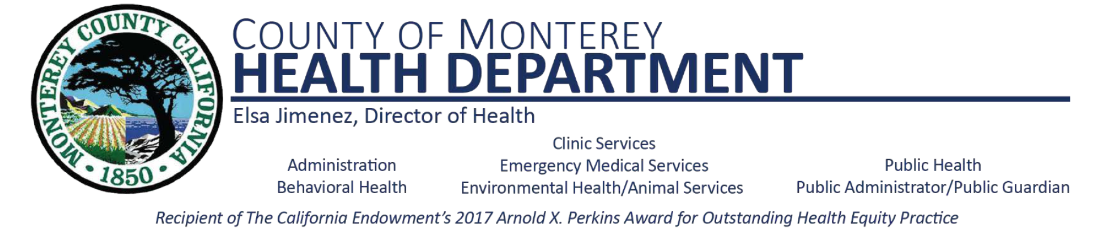

**Oral Health Advisory Committee Meeting**

**Agenda**

Wednesday, September 7th, 2022

1:00 pm –2:00pm

1. Welcome & Introductions
2. Partners & Agency Announcements
3. Clinical – Dental Screenings
4. Student Presentations
5. Identified Target Schools
6. Outreach & Education
7. Meeting Adjourn