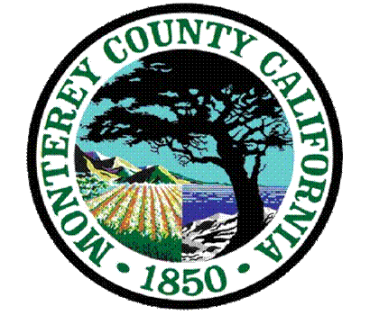
County of Monterey

Application for a Tobacco Retail License

Authority: Monterey County Code 7.80

July 22, 2023

Monterey County requires a Tobacco Retailer License to sell tobacco products in the unincorporated areas of the County. Likewise, the cities of Salinas, Carmel, Monterey, Pacific Grove, Gonzales, Seaside, King City, Soledad, and Marina require tobacco retailers to hold the County Tobacco Retailer License to sell tobacco products. The tobacco Retailer License is granted and administered by the Monterey County Health Department to ensure compliance with county, city, state, and federal tobacco laws. The fee is $384 and is paid annually. This license is required in addition to a California Department of Tax and Fee Administration Tobacco Retailer’s License. You need both licenses.

Please mail the following items to receive the Tobacco Retailer License:
- A completed and signed application
- Check or money order for $384 made payable to County of Monterey
- Copy of your California Department of Tax and Fee Administration Tobacco Retailer’s License
- A copy of the California Electronic Cigarette Excise Tax Permit (if you sell Electronic Cigarettes)
- Mail to: Tobacco Control Program: 1441 Schilling Pl, Salinas, CA 93901

If this application is for a new business or change of ownership, you must also submit:

- The Monterey County Health Department Environmental Health Bureau application
- The Workers’ Compensation Compliance Affirmation form

Please note:
- You must have the required Tobacco Retailing License before selling tobacco products; owner/s will be subject to penalties for tobacco retailing without a license.
- Your Tobacco Retail License must be posted inside your store in a location visible to the public.
- Each Tobacco Retail Location must have a separate license.
- The license is non-transferable.
- It is a violation of the Monterey County Tobacco Retail License for a retailer to violate any federal, state, or local tobacco law or regulation.

For questions about the application pertaining to tobacco retailing, please contact the Tobacco Control Program at (831) 755-4695 or send an email to barreramr@co.monterey.ca.us.

For questions regarding obtaining your tobacco retail license after submission of your application, please contact the Environment Health Program.

Salinas: 1270 Natividad Road, Salinas, CA 93960
Office (831)755-4505 - Fax (831)796-8694
Monterey: 1200 Aguajito Rd, #007, Monterey, CA 93940
Office (831)647-7654 - Fax (831)796-8695
King City: 200 Broadway, Ste 70, King City, CA 93930
Office (831)386-6899 - Fax (831)796-8697

Please visit www.mtyhd.org/trl to view and/or print TRL ordinance and Frequently Asked Questions.

Thank you for your cooperation in working with us to reduce illegal tobacco sales to minors.
_________________________________
Maggie Barrera
(831) 755-4695
Chronic Disease Prevention Specialist II
Tobacco Retail Program

