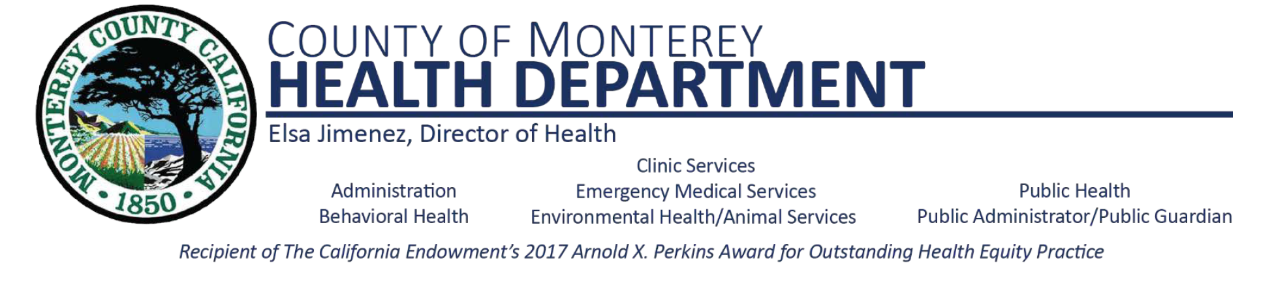

**Oral Health Advisory Committee Meeting**

**Agenda**

Wednesday, March 8th, 2023

1:00 pm –2:00pm

1. Welcome & Introductions
2. Partners & Agency Announcements
3. County Clinic Services Collaboration: Oral Health Literacy Campaign
4. Student Presentations
5. Parent Outreach & Education
6. New Business
7. Meeting Adjourn