**STATE OF CALIFORNIA**  
APPLICATION

FOR  
DOMESTIC WATER SUPPLY PERMIT AMENDMENT

FROM

Applicant:

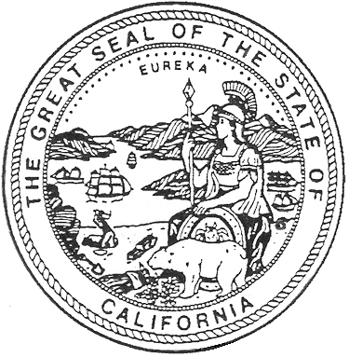

(Enter the name of legal owner, person(s) or organization)

Address:

System Name:

System Number:

TO: **MONTEREY COUNTY HEALTH DEPARTMENT**

**ENVIRONMENTAL HEALTH BUREAU**

**1270 NATIVIDAD ROAD**

**SALINAS, CA 93906**

Pursuant and subject to the requirements of the California Health and Safety Code, Division 104, Part 12, Chapter 4 (California Safe Drinking Water Act), Article 7, Section 116550,

relating to changes requiring an amended permit, application is hereby made to amend an

existing water supply permit to

(Applicant must state specifically what is being applied for - whether to construct

new works, make alterations or additions in works or sources, or change or modify treatment.)

I (We) declare under penalty of perjury that the statements on this application and on the accompanying attachments are correct to my (our) knowledge and that I (we) are acting under authority and direction of the responsible legal entity under whose name this application is made.

Signed By:

Title:

Address:

Telephone:

Dated: DDW: 05/2000