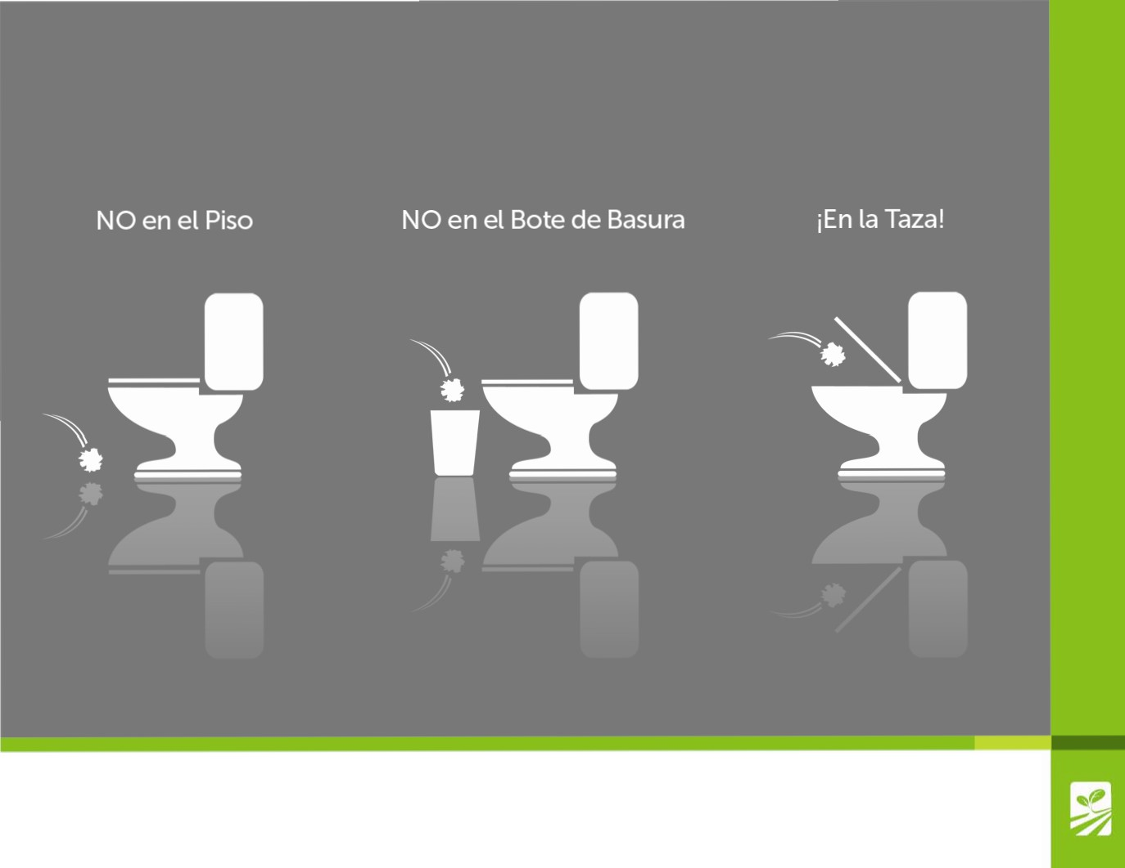

**Harvesting Safe**

**Papelde Baiio**

Arizona Leafy Greens