Visual Analysis

Paraiso Hot Springs

PLN040183

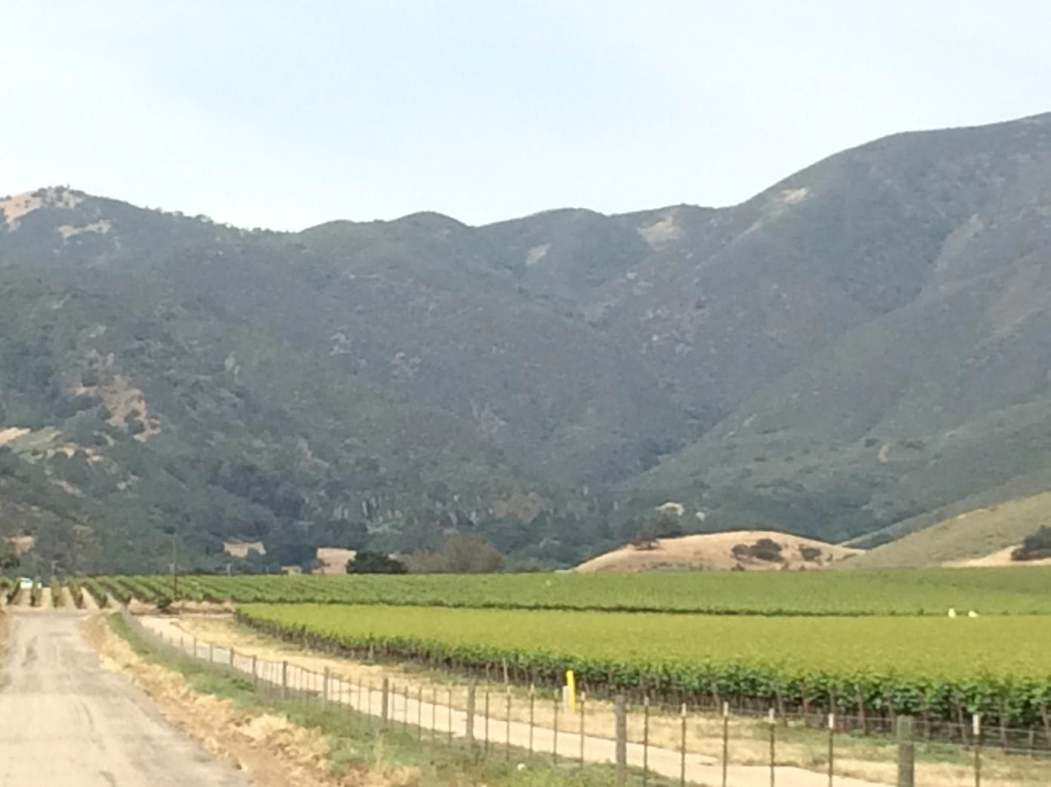

Prepared by

County of Monterey – Resource Management Agency December 1, 2016

INTRODUCTION

This analysis was undertaken to address the potential visual impact of constructing a 103 room hotel, multiple restaurants, spa, sport courts, meeting rooms and support facilities, 60 time share condominiums, 17 single family dwelling time share villas, a Day Spa and Fitness Center, Wine Pavilion and Visitor Center on 235 acres located at the end of Paraiso Springs Road, west of the Cities of Soledad and Greenfield. This study was undertaken as part of the preparation of a Recirculated Environmental Impact Report for this project. As such, the focus of the study is the regulatory setting for Monterey County and the findings required in Appendix G of the CEQA Guidelines.

1. Regulatory Context

The project is subject to the 1982 Monterey County General Plan due to the timeframe in which the application was deemed complete. The project location is within the Central Salinas Valley Area Plan, located on the western side of the Salinas Valley in the Sierra de Salinas Foothills. While Figure 5 of the Central Salinas Valley Scenic Highways and Corridors Map of the Central Salinas Valley Area Plan identifies the site as being within an area designated as Highly Sensitive, there are no existing or proposed scenic highways or roads in proximity to the site or within the Central Salinas Valley Area Plan.

The 1982 Monterey County General Plan, which governs the analysis and decisions on this application, states: *Visually sensitive areas of the Central Salinas Valley include the foothills of the Gabilan and Sierra de Salinas Mountains, Pine Canyon, Chualar Canyon, Arroyo Seco watershed, and the Salinas Valley floor. Areas identified as highly sensitive are those possessing scenic resources which are most unique and which have regional or countywide significance. The highly sensitive areas in Figure 5 are so designated because the prominence of the ridgelines and frontal slopes with their unique vegetation are important in giving the Planning Area its rural character. Other highly sensitive areas are found along the Arroyo Seco River.*

The General Plan places an emphasis on the prominence of the frontal slopes and the unique vegetation of this area. Development that would significantly modify these features would not be consistent with Policy 26.1.6.1 of the Central Salinas Valley Area Plan (below); development may be visible, but it should not constitute a significant deviation in natural views from the public viewing perspective.

*Policy 26.1.6.1: Development shall have appropriate review where it is permitted in sensitive or highly sensitive areas as shown on the Scenic Highways and Visual Sensitivity Map.*

1. Methodology

On May 4, 2016, County of Monterey RMA staff (John Ford, RMA Services Manager, and Dan Lister, Assistant Planner) conducted a field analysis to determine the visibility of the site from surrounding roadways. At the time of the field survey, the early morning weather was characterized by a foggy marine layer, which lifted by the time the analysis was conducted between the hours of 9:30 – 11:00 am. The visibility was unobstructed with clear skies, no discernable wind, and no dust.

In order to maintain a consistent point of reference, a large orange traffic warning sign (approximately 5’ X 5’) was placed on the ridge at a location among where the 2 and 3 bedroom time share villas are proposed. This sign was at approximately the same elevation as the top of the palm trees existing in the valley in the location of the hotel. The visibility was then documented by driving the roads in the area to identify from where the site is and is not visible. Pictures were taken at each of these locations to document the visibility of the site. The orange sign was visible with the unaided eye from the locations documented and barely visible from Highway 101 (location 1). Unfortunately, the orange sign does not show up in the pictures.

The following picture was taken from the location where the sign was placed looking out into the Salinas Valley:

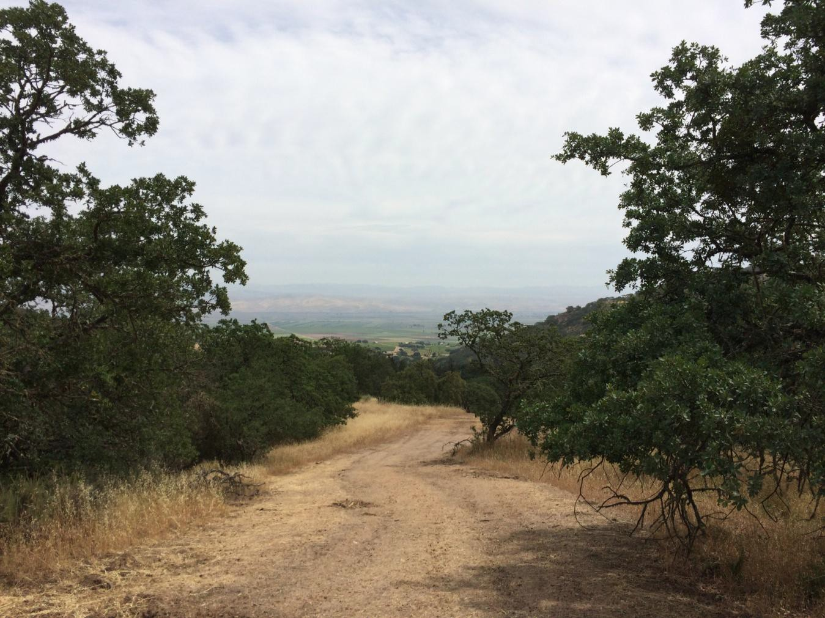

The off-site area was then visually surveyed to determine the points at which the proposed development (site) could be visible and where the site could no longer be seen. The locations from where the pictures were taken were provided to the applicant, who worked with the project architect to provide photo renderings of the site from these locations (See Exhibit 1). The conclusion of this visual analysis uses a combination of the site visit observations, documentary photos and photo simulations.

The following map shows the locations from where the site was documented as being visible:

Figure 1

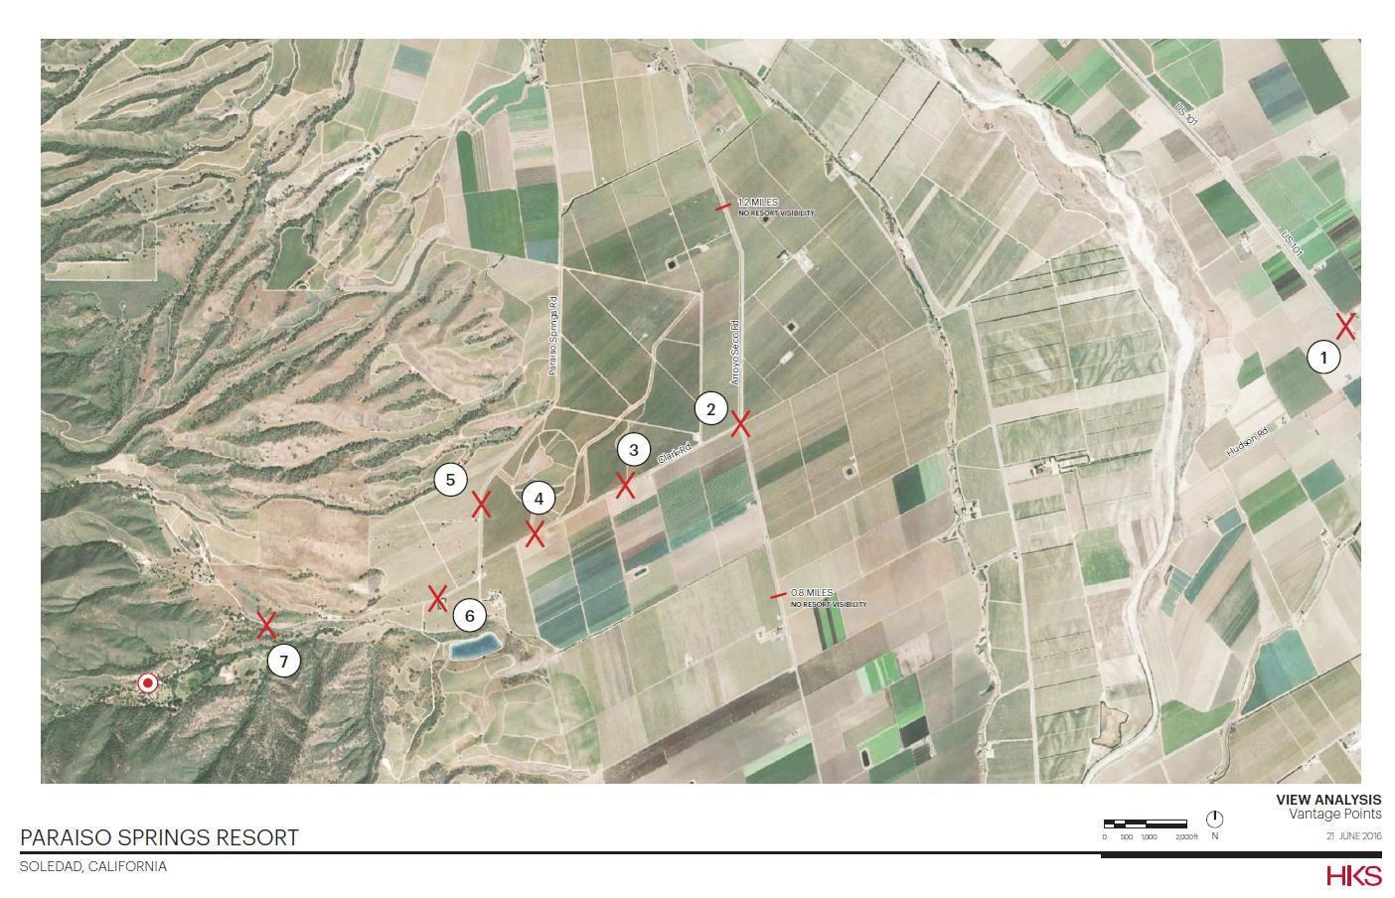

ANALYSIS

The location of the site within a valley tucked in the side of the foothills limits the visibility of the site from the north and the south. The primary visibility of the site is from an angle that allows the observer to look up into the valley. Based upon this the visibility of the site can be broken into three distances: near visibility, mid-range visibility and long-range visibility, which are defined as follows:

* 1. Near Visibility: At this distance the observer will be able to see the buildings individually without any loss of definition due to distance.
  2. Mid-Range Visibility: A distance where the definition of the buildings begin to blend into a mass.
  3. Long-Range Visibility from Highway 101: A distance difficult to discern the project components other than as a mass, but the location from which the highest number of observers will view the site.

**Near Visibility (Locations 7, 6 and 5 of Figure 1)**

Visibility of the site will be limited within one mile of the site due to the vegetation and topography along Paraiso Springs Road, which do not yield clear views of the site. Progressing from the project site, the first location where the site is visible is identified as location 7. From this location, the public that is able to see the site will be limited to people traveling to the resort and local residents.

The project will be visible from location 6 to approximately one quarter mile north of Clark Road, which is marked as location 5. The vista along Paraiso Springs Road south of Clark Road looks directly up the valley at the site. The topography surrounding the site cuts off visibility of the site north of location 5 on Paraiso Springs Road. As the photo simulation in Exhibit 1 of the site in location 5 shows, the site is only visible once the site is not blocked by the low lying hill north of the entrance.

**Existing Visibility of the Project Site**

The dominant visual markers on the site are the mature palm trees planted during the resort era of the site. From location 7, a combination of native vegetation and the palm trees are the only features truly visible. The same is true from location 6. In location 6 the site is seen in the context of lower hillsides to the north and south of the valley. The ridgeline forming the northern boundary of the site is very visible from this location; however, this is the only feature visible from location 5.

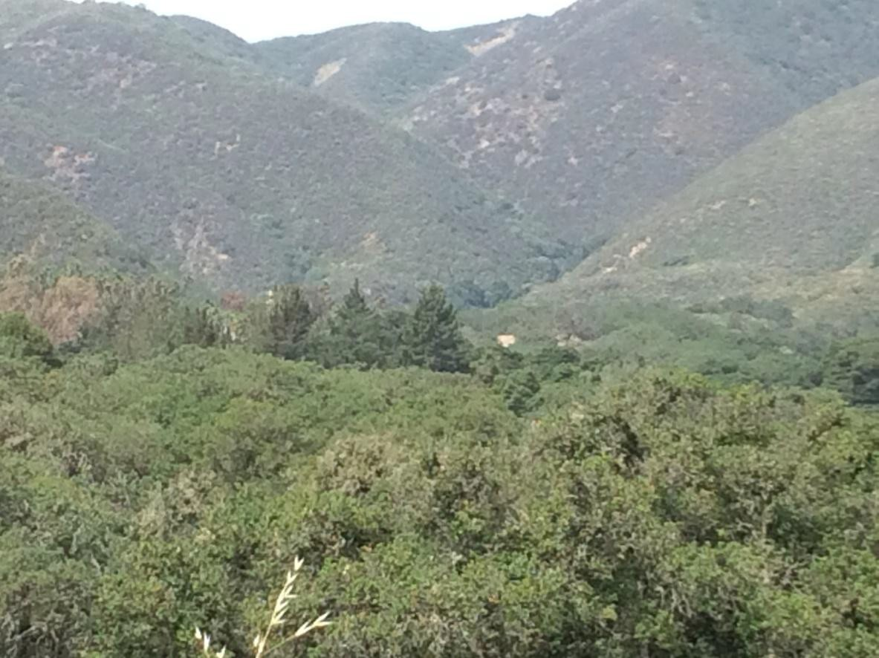

Photo from Location 7.

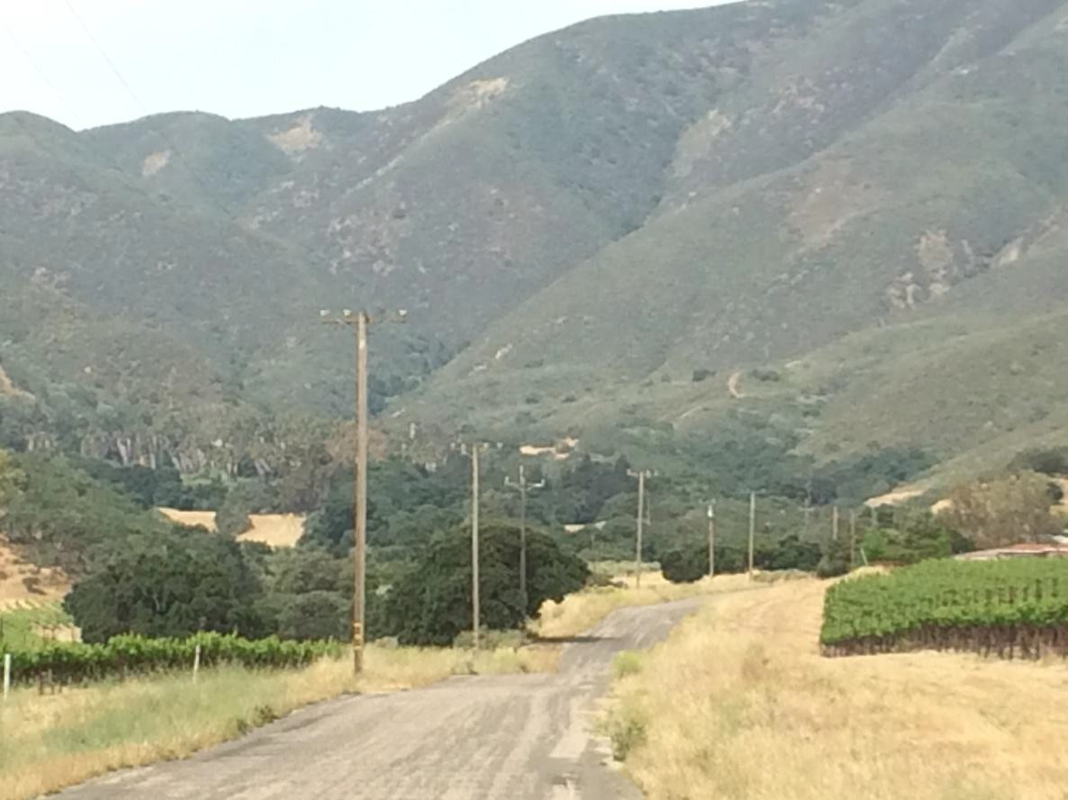

Photo from Location 6

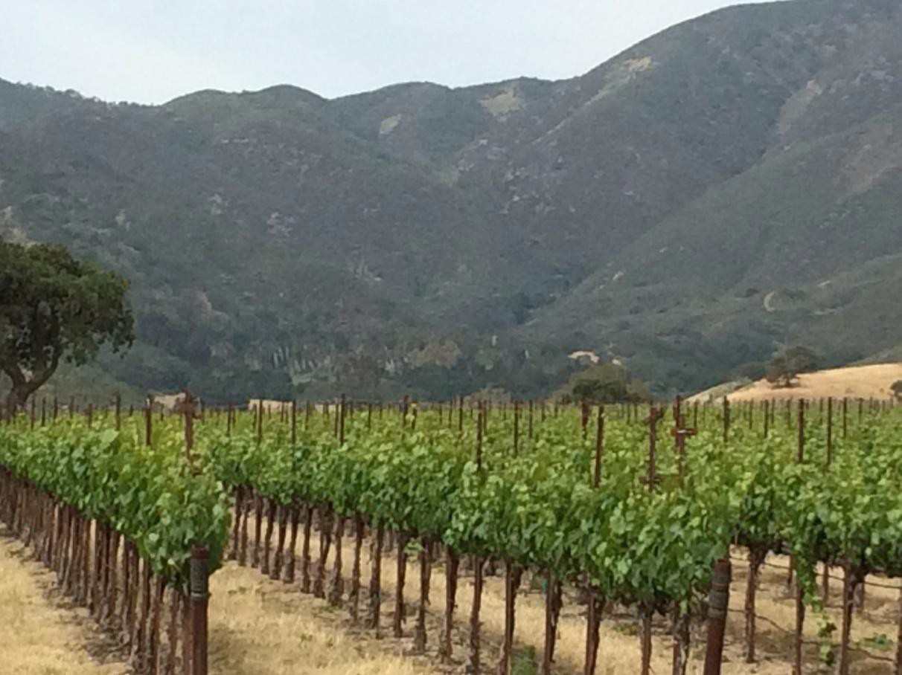

Photo taken from Location 5

**Visual Impact of Proposed Project**. From location 7 the roofs of the hotel, spa and day use areas will be visible as shown in the photo rendering in Exhibit 1, Page 29, and the condominiums on the hillside framing the north side of the site will be fully visible from this location. From location 6, portions of the hotel, spa and day use areas will be visible, and the condominiums on the hillside will be visible (see pages 25-27 of Exhibit 1). From location 5, the site becomes less visible with most of the visual impact from the hillside condominiums. At this location the remainder of the site will only be slightly visible as evidenced by the visual simulation on Page 21 of Exhibit 1.

A project design alternative has been prepared (Page 22 of Exhibit 1) showing the visual impact of the site with removal of the condominiums from the hillside along the northern edge of the site. This alternative will reduce the visual impact of development on the hillside. If this alternative is adopted then the units will be relocated to a lower elevation where they will not be visible.

**Mid-Range Visibility (Locations 4, 3 and 2 of Figure 1 above)**

Clark Road almost lines up with the valley in which the proposed resort is located. Visibility along this road looks right up the valley at the site. While Clark Road undulates, the undulations are not sufficient to obstruct visibility of the site along the entire length of Clark Road. This is reflected in the photos below and the photo view studies for locations 2, 3, and 4 in Exhibit 1. The site will be most visible from these locations. Location 2 is at the intersection of Clark Road and Arroyo Seco Road. Visibility of the site from this vantage point will be limited to approximately a two

mile stretch of Arroyo Seco Road extending from 1.2 miles north of Clark Road to approximately 0.8 miles south of Clark Road.

**Existing Visibility** **of the Project Site**. The primary visual component of the existing site from this distance is the hillsides to the north and the south of the project site framing the palm trees on the site. These are seen in the context of the Santa Lucia Mountain Range in the background.

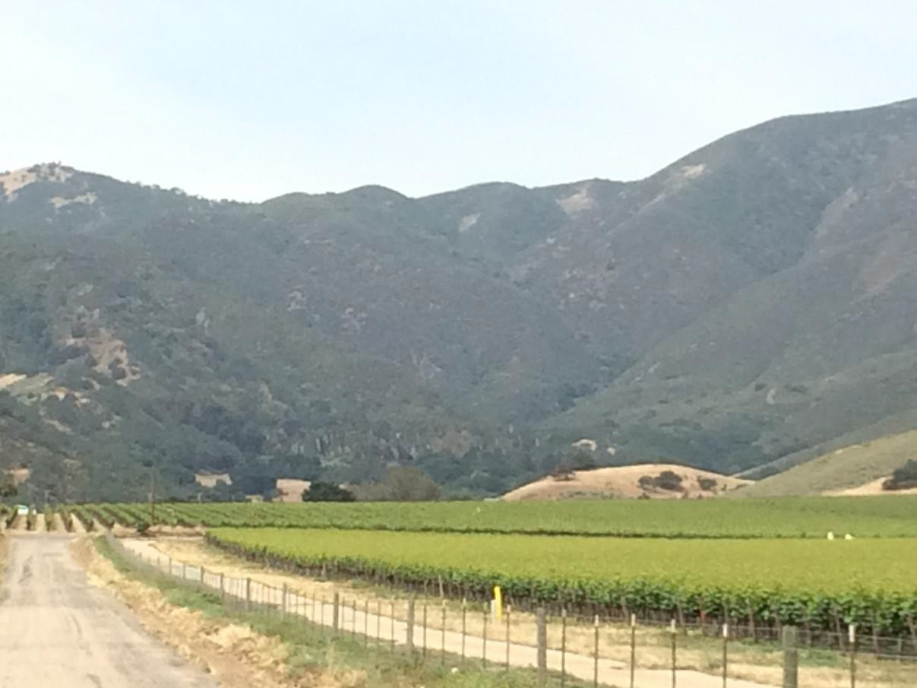

Location 4

**Visual Impact.** At this distance the proposed individual buildings become less visible, but the visibility of the rooftops becomes more pronounced as the natural topography rises up the valley floor and the buildings correspondingly increase in elevation. The rooftops of each succeeding building will be visible, and from increasing distances, the rooftops will appear more as a single mass of buildings on the landscape. This will be most pronounced from location 2 at Arroyo Seco Road. At this distance the buildings will have the potential to create a distinct break in the vegetation cover, which is part of the unique scenic resource in this location. The project proposes significant grading to achieve gradients and pads for structures, but significant landforms will not be altered and will not cause a change in topographical appearance from off-site view areas.

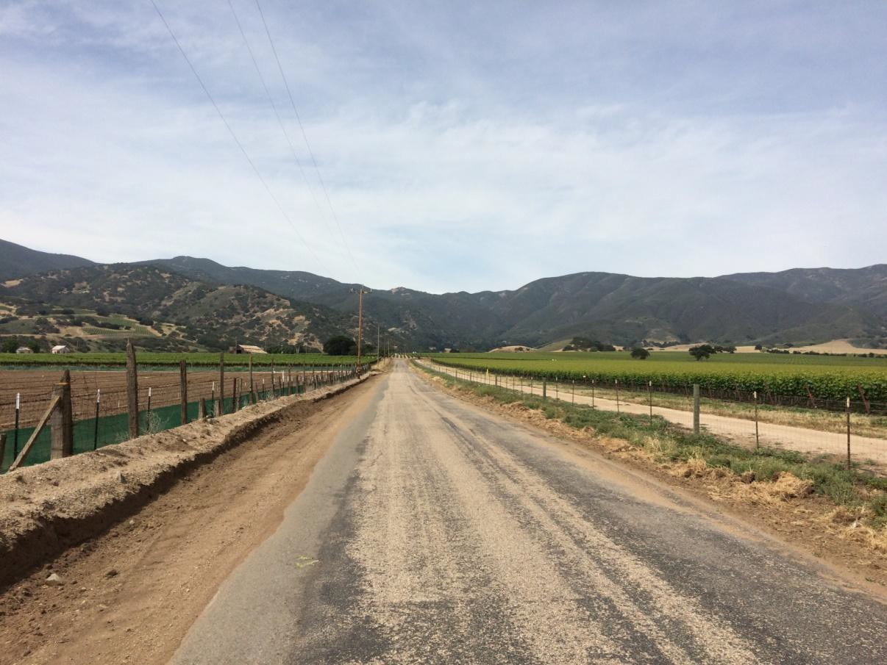

Location 3

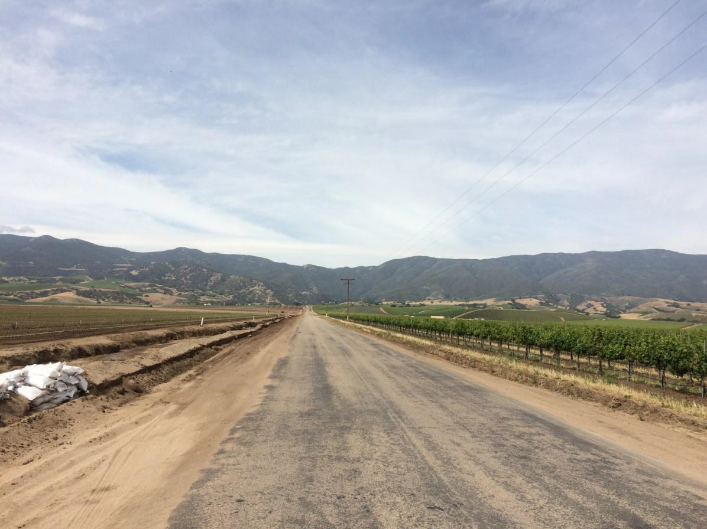

Location 2

**Long-Range Visibility from Highway 101 (Location 1 of Figure 1)**

There will be a stretch of Highway 101 that will afford limited views of the site due to the distance. This is reflected in view study 1 of the Exhibit.

**Existing Visibility**. The site from this distance is within a discernible valley on the side of the Sierra de Salinas Foothills. The surrounding steep slopes frame the valley at which point the existing palm trees are visible to the unaided eye.

**Visual Impact.** At this distance the primary visual impact will be a disruption in the natural vegetation pattern and the buildings will appear as masses against the foothills. The existing palm trees already alter the existing vegetation but this is not noticeable to the traveling public at this distance. The proposed project has the potential, as discussed above for location 2, to create a break in the appearance of the natural landscape.

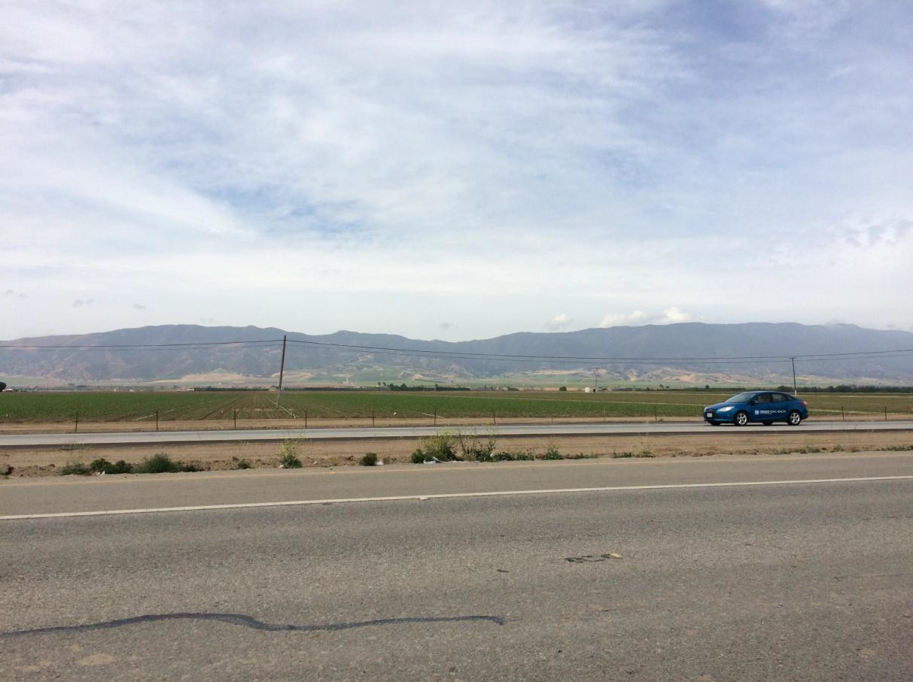

Location 1

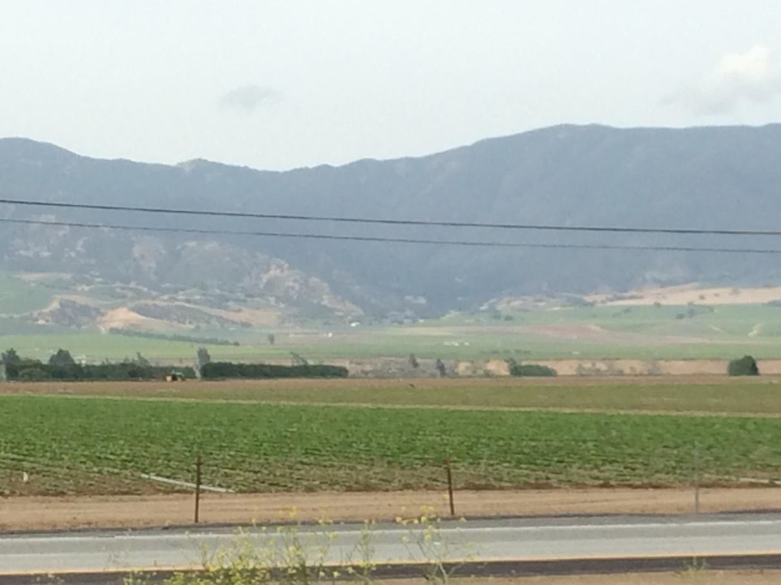

Location 1 (Zoom view for purpose of location identification—not relevant to analysis, which requires analysis by unaided vision)

FINDINGS

The findings of this study will follow the CEQA appendix G questions.

1. *The project will not have a substantial adverse effect on a scenic vista.* There are no designated scenic vistas in this location; there are no designated or proposed scenic roads.
2. *The project does not have the potential to substantially damage scenic resources, including, but not limited to, trees, rock outcroppings, and historic buildings within a state scenic highway.* There are no scenic highways from which this project would be visible.
3. *The project does have the potential to substantially degrade the existing visual character or quality of the site and its surroundings.* The 1982 Monterey County General Plan identifies the site as Visually Sensitive. This designation is based on the prominence of the frontal slopes and the unique vegetation of this area. A project that has the potential to significantly detract from the appearance of the slopes and vegetation would constitute a potentially significant impact. Grading of the site will not change the overall topography, but the implementation of the project has the potential to interrupt the vegetation patterns with a large mass of buildings. This has the potential to be a significant impact.

Project design and colors can significantly mitigate or compound this potential impact. The renderings prepared for the project include mission style architecture using a red terra cotta

tile roof and white plaster. These colors will make the project more visible, and highlight the loss of vegetation. This has the potential to be a significant adverse impact. This impact can be mitigated to a less than significant level with mitigation that includes the following:

* 1. The roof color shall include a blend of darker shades, which colors would serve to blend the building’s rooftops into the natural environment and reduce the appearance of large masses from greater distances. An alternative color palette has been provided by the applicant in Exhibit 1, page 2. Final design shall be subject to review and approval of the RMA Director.
  2. The color of the plaster shall utilize a variety of earth tone colors, such as the color supplied in the palette on page 2 in the referenced Exhibit, and as otherwise approved by the RMA Director.
  3. The Landscape Plan shall include the use of five-gallon size or transplanted Native Oak Trees planted to break up the building rooflines and the front of the resort when viewed from the Salinas Valley, while allowing well-designed openings in the canopy to allow views from the resort of the valley.

The intent of this mitigation measure is only to occasionally break up the mass, not screen the site from the valley, and to use color and vegetation to break up the visual massing from mid-range and long-range views. This can be achieved by using existing topography, landscape plantings, and a variety of colors to create variety in the mass.

1. The Project has the potential to create a new source of substantial light or glare, which could adversely affect day or nighttime views in the area. The DEIR addressed this issue by requiring all lighting to be screened. The outcome desired for this measure is to ensure that resort exterior lighting is shielded or directed so that the light source is not visible from Arroyo Seco Road and from Highway 101. For exterior lights attached to buildings, this may include shielding, lighting facing away from these roads, or light sources recessed into fixtures. This will be a requirement of the project site development through review of lighting plans approved by the RMA Director.