
MONTEREY COUNTY HEALTH DEPARTMENT
ENVIRONMENTAL HEALTH BUREAU

APPLICATION FOR GRAYWATER IRRIGATION

OR DISPOSAL SYSTEM PERMIT

Monterey County Code, Chapter 15.20

Please review Chapter 15 of the California Plumbing Code
for system design requirements before completing this form.

Assessor’s Parcel No. |  | - - -000 | System Description:
Site Address:
Owner’s Name |  |  |  |  | Phone #
Mailing Address:
Water Company: |  |  |  | Sewer Company:
(OR INDICATE ‘PRIVATE WELL’ or ‘SHARED WELL’) (OR INDICATE ‘SEPTIC SYSTEM’)
Graywater system is proposed to serve:
Single Family Residential | Multiple Unit / Community
List all fixtures: | List all fixtures:
Tank
Daily Graywater Flow: gallons |  | Surge Tank Capacity: gallons
Summary of section 1502.8.1 from Chapter 15, CPC regarding Graywater Calculations:
The number of occupants of each dwelling unit shall be calculated as follows: | The estimated graywater flows of each occupant shall be calculated as follows:
  First bedroom | 2 occupants
  Each additional bedroom | 1 occupant
  Showers, bathtubs, and wash basins | 25 GPD/occupant
  Laundry | 15 GPD/occupant
The total number of occupants shall be multiplied by the applicable estimated graywater discharge as provided above and the type of fixtures connected to the graywater system. For example, a 3 bedroom house is considered to have 4 occupants. Four occupants taking a daily shower will be expected to generate 100 gallons/day.
Irrigation / Disposal Field
Topography: | Flat < 30% slope > 30% slope (Variance Required)
Description: | Total square feet: |  | Multiple Irrigation Fields: Yes No If yes, how many?
 | Drip line | Number: |  | Length: ft. | Cover Depth: in.
 | Mulch basins | Number: |  | Area: ft. | Cover Depth: in.
 | Other:
I certify that I have read and understand the California Plumbing Code Chapter 16 requirements for graywater irrigation or disposal systems. I understand that if there is a complaint investigation that verifies a violation of the applicable standards, then the property owner will be subject to cost recovery and any fines resulting from the investigation (Calif. Health & Safety Code Section 510).

__ _________________________________________________________ __ ____________________________
Signature of Property Owner Date

For Office Use Only |  | Date Permit Fee Received Is The Date Of Issuance.
FEES: Health Permit Fee $ | Receipt Number: | Date Permit Fee Received: Name:
Plans Approved By: |  | Date Plans Approved:
Environmental Health Specialist
Revised 06/05/2018

Address: ___________________________________________________

Using the graph below, indicate where on the property the graywater will be used (see sample site plan on the next page). Indicate setbacks to property lines, house and other structures, drainage ways, 30% slopes, and drinking water lines (minimums are given in Table 2 on page 7 of the Permitting Guidelines). Show street frontage and your driveway.

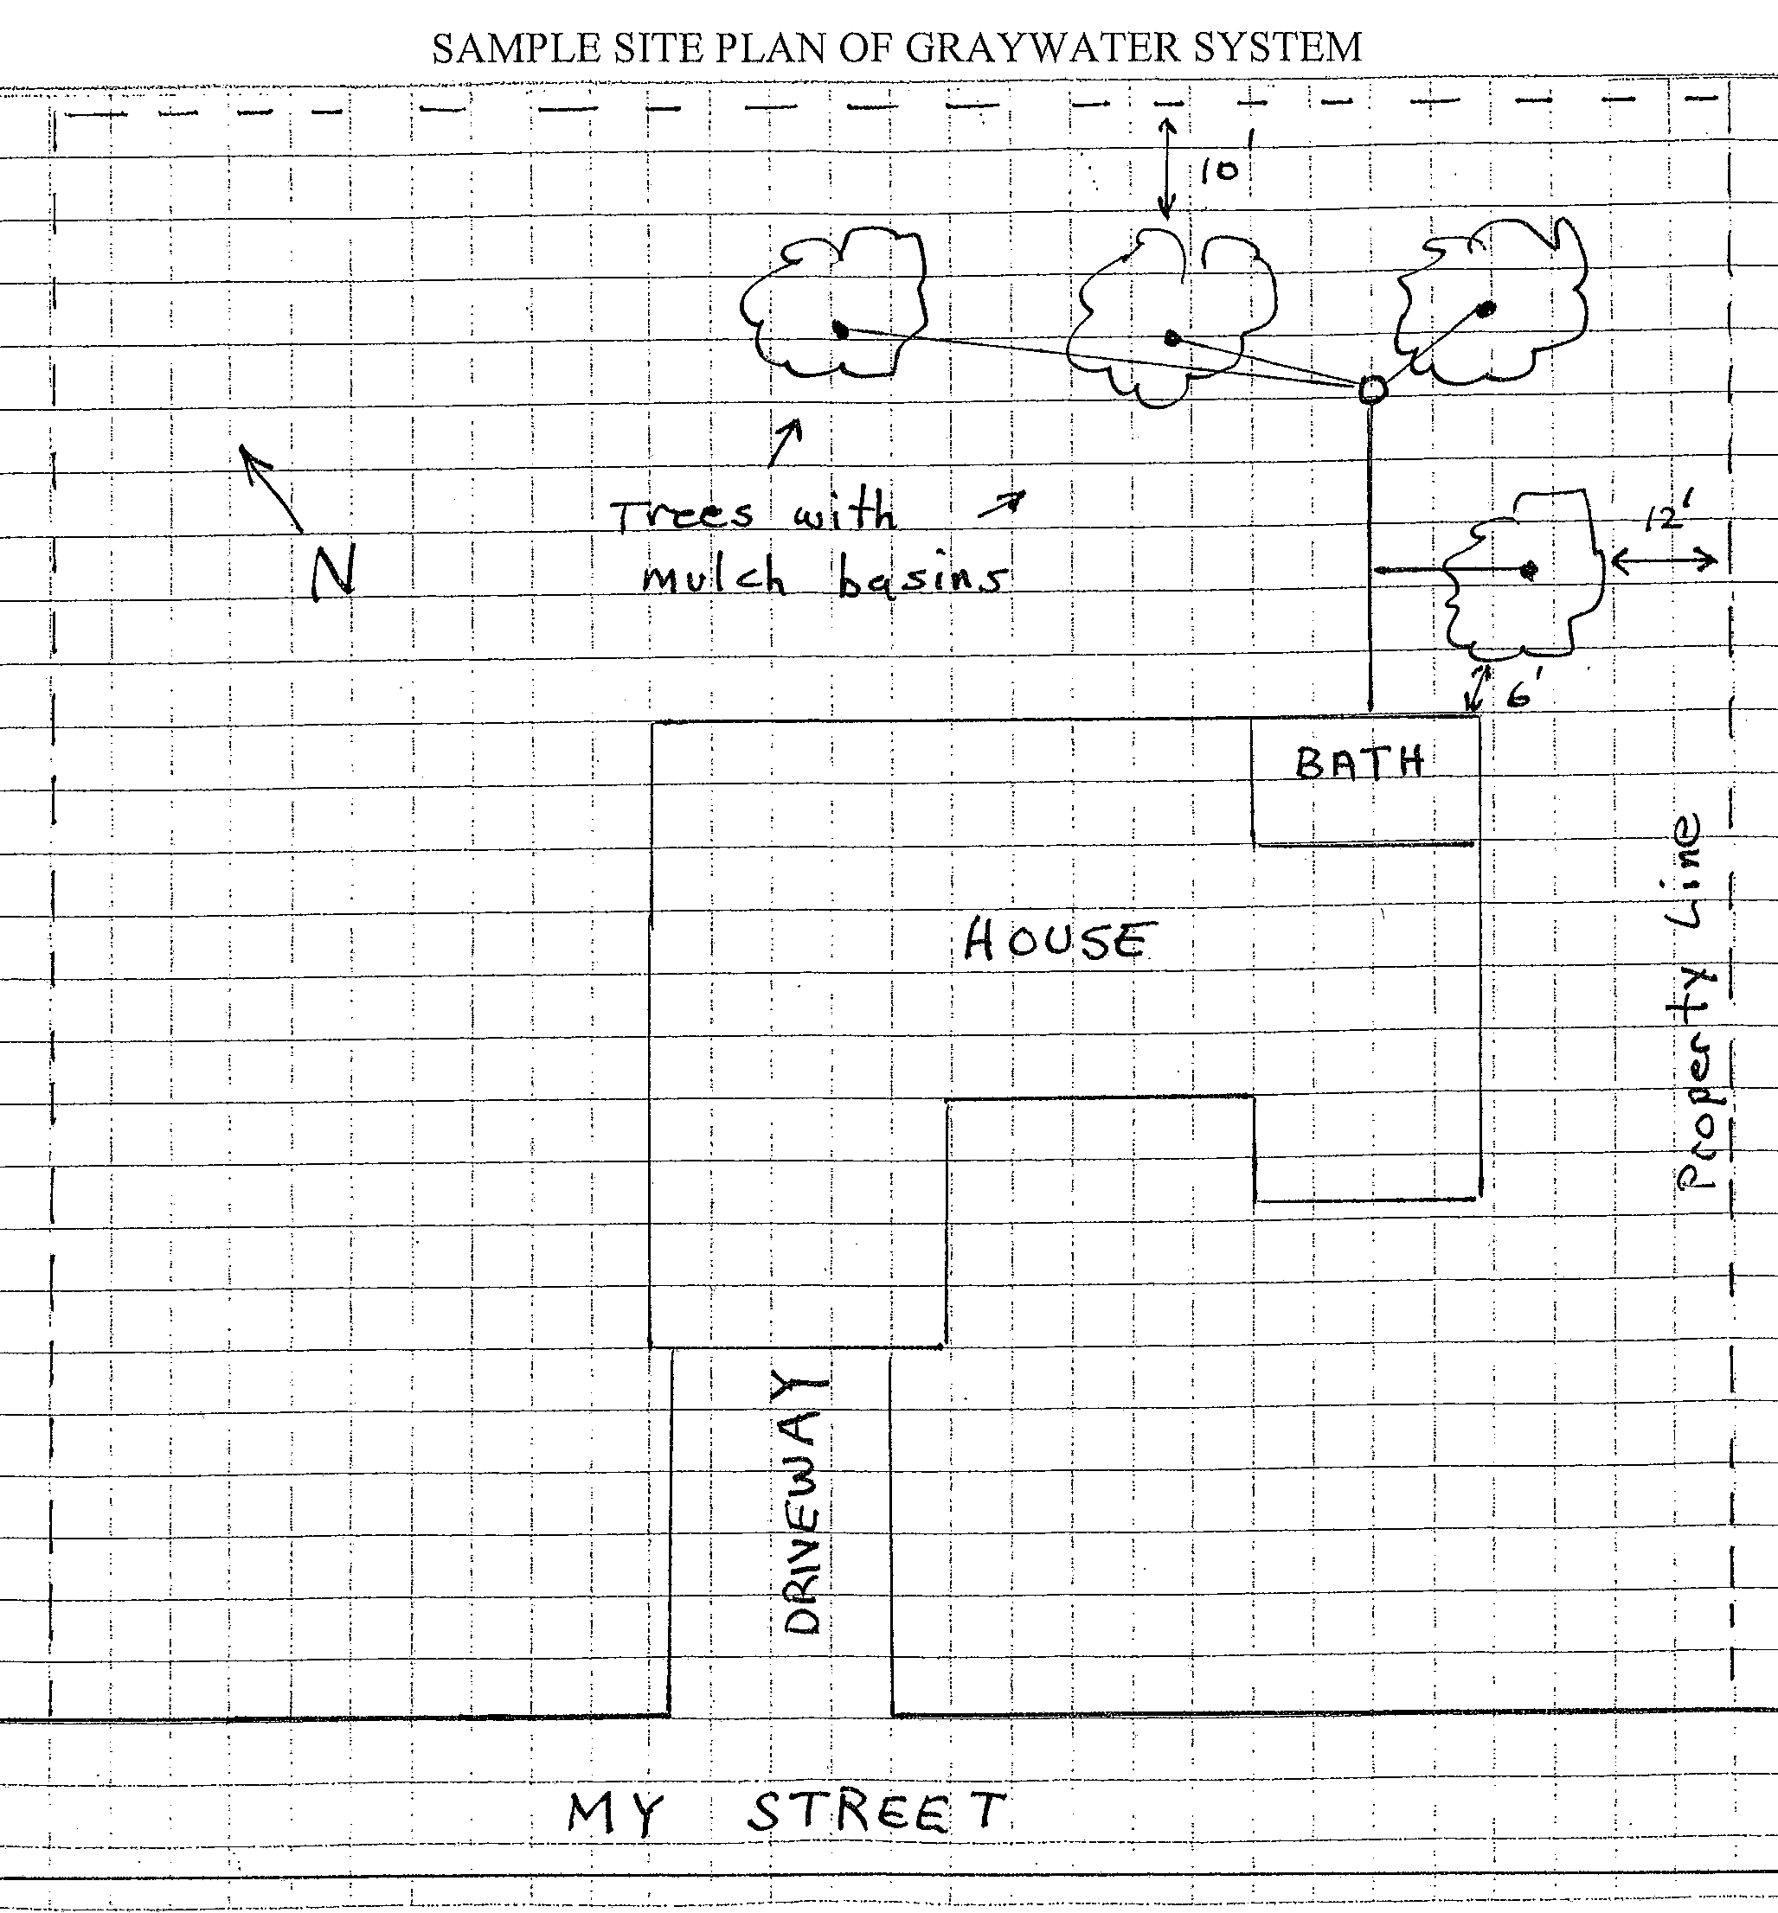

SIMPLE GRAVITY GRAYWATER IRRIGATION SYSTEM INSTALLATION CHECKLIST

INDOOR FIXTURE CONNECTION
- BATHROOM SINK BATHTUB OTHER:
- CLEARLY-MARKED 3- WAY VALVE TO DIRECT WATER
FROM GRAYWATER SYSTEM TO SEWER? YES NO
- ANY FRESH WATER CONNECTION TO STORAGE TANK? YES NO
- DOES SYSTEM INCLUDE A PUMP? YES NO
COMMENTS:
SURGE/ STORAGE TANK
- DOES THE SYSTEM INCLUDE A SURGE TANK? YES NO
- TANK CAPACITY LESS THAN 250 GALLONS? YES NO
- TANK AND IRRIGATION SYSTEM DESIGNED TO EMPTY COMPLETELY IN 24 HOURS? YES NO
- TANK OVERFLOW CONNECTED TO SEWER? YES NO

OUTSIDE PIPING AND SPIGOTS
1. ARE ALL GRAYWATER PIPES AND SPIGOTS LABELLED “NON-POTABLE WATER,
DO NOT DRINK ?” YES NO

DISPOSAL/IRRIGATION FIELDS
- SLOPE OF TOPOGRAPHY? FLAT < 30% > 30%
- IRRIGATION FIELD MEETS SETBACKS TO WELLS, SEPTIC SYSTEMS, WATERCOURSES, PROPERTY LINES, AND STRUCTURES? YES NO
- IRRIGATION TUBING / MULCH BASIN COVER DEPTH: [MINIMUM 2”] TYPE OF COVER:

OWNER”S MANUAL
- REQUIRED OPERATION AND MAINTENANCE MANUAL COMPLETED? YES NO

Revised 06/05/2018

